**Machine Learning Model Deployment with IBM Cloud Watson Studio**

**Team member**

**732721104060 : Vijitha M**

**Phase 3 Submission Document**

**DEVELOPMENT PART 1**



**Introduction:**

* Deploying a customer churn prediction machine learning model through IBM Cloud Watson Studio is a transformative process.
* This project will guide you through the key stages of preparing your data and deploying a predictive model using Watson Studio.
* The ability to anticipate customer behavior and optimize business strategies is at the core of this journey, and it all begins with efficient data preprocessing and model deployment.
* In this document, we focus on the initial phase of our project, which involves Data Preparation and Collection. This crucial step is dedicated to gathering and refining data for subsequent analysis and modelling.

**Given data set:**

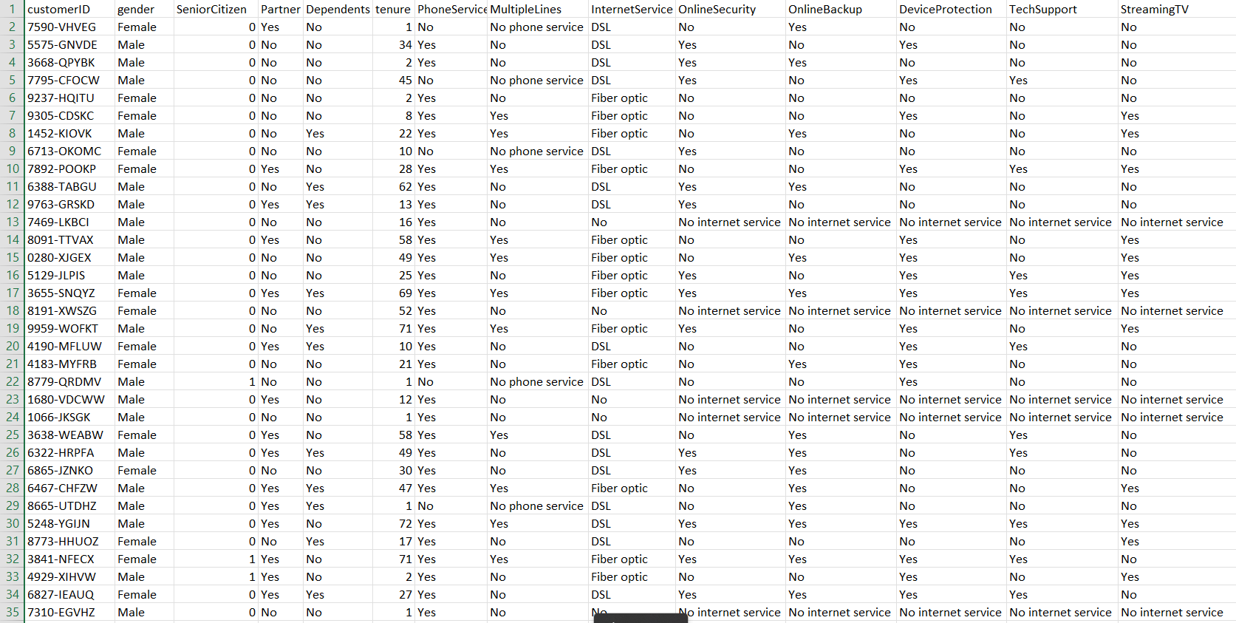

**Dataset Info:**

Sample Data Set containing Telco customer data and showing customers left last month

**In [1]:**

***#import the required libraries***

**import** numpy **as** np

**import** pandas **as** pd

**import** seaborn **as** sns

**import** matplotlib.ticker **as** mtick

**import** matplotlib.pyplot **as** plt

**%matplotlib** inline

**Load the data file:**

**In [2]:**

telco_base_data **=** pd**.**read_csv('ML Model Dataset.csv')

**Look at the top 5 records of data**

**In [3]:**

telco_base_data**.**head()

**OUT [3]:**

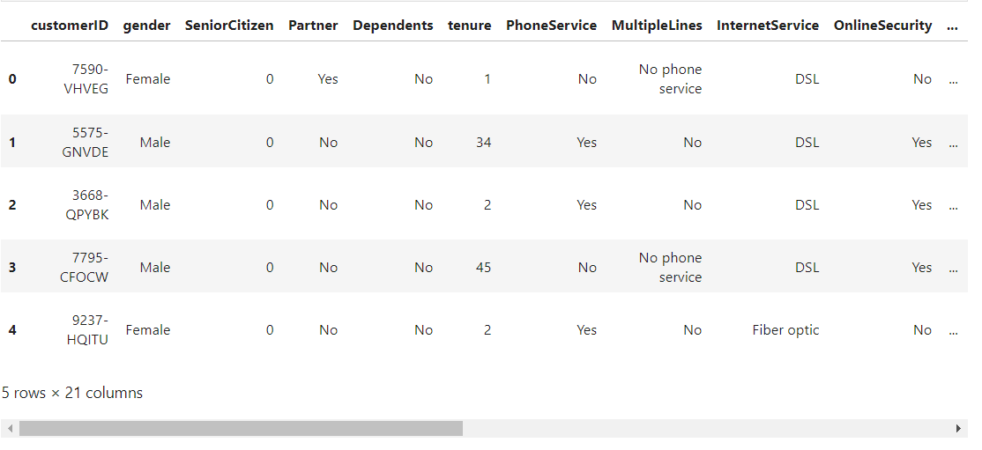

Check the various attributes of data like shape (rows and cols), Columns, datatypes

**In [5]:**

telco_base_data**.**shape

**Out[5]:**

(7043, 21)

**In [6]:**

telco_base_data**.**columns**.**values

**Out[6]:**

array(['customerID', 'gender', 'SeniorCitizen', 'Partner', 'Dependents',

'tenure', 'PhoneService', 'MultipleLines', 'InternetService',

'OnlineSecurity', 'OnlineBackup', 'DeviceProtection',

'TechSupport', 'StreamingTV', 'StreamingMovies', 'Contract',

'PaperlessBilling', 'PaymentMethod', 'MonthlyCharges',

'TotalCharges', 'Churn'], dtype=object)

**In [7]:**

***# Checking the data types of all the columns***

telco_base_data**.**dtypes

**Out[7]:**

customerID object

gender object

SeniorCitizen int64

Partner object

Dependents object

tenure int64

PhoneService object

MultipleLines object

InternetService object

OnlineSecurity object

OnlineBackup object

DeviceProtection object

TechSupport object

StreamingTV object

StreamingMovies object

Contract object

PaperlessBilling object

PaymentMethod object

MonthlyCharges float64

TotalCharges object

Churn object

dtype: object

**In [8]:**

***# Check the descriptive statistics of numeric variables***

telco_base_data**.**describe()

**Out[8]:**

|  | **SeniorCitizen** | **tenure** | **MonthlyCharges** |
| --- | --- | --- | --- |
| **count** | 7043.000000 | 7043.000000 | 7043.000000 |
| **mean** | 0.162147 | 32.371149 | 64.761692 |
| **std** | 0.368612 | 24.559481 | 30.090047 |
| **min** | 0.000000 | 0.000000 | 18.250000 |
| **25%** | 0.000000 | 9.000000 | 35.500000 |
| **50%** | 0.000000 | 29.000000 | 70.350000 |
| **75%** | 0.000000 | 55.000000 | 89.850000 |
| **max** | 1.000000 | 72.000000 | 118.750000 |
|  |  |  |  |

**SeniorCitizen is actually a categorical hence the 25%-50%-75% distribution is not propoer**

**75% customers have tenure less than 55 months**

**Average Monthly charges are USD 64.76 whereas 25% customers pay more than USD 89.85 per month**

**In [9]:**

telco_base_data['Churn']**.**value_counts()**.**plot(kind**=**'barh', figsize**=**(8, 6))

plt**.**xlabel("Count", labelpad**=**14)

plt**.**ylabel("Target Variable", labelpad**=**14)

plt**.**title("Count of TARGET Variable per category", y**=**1.02);

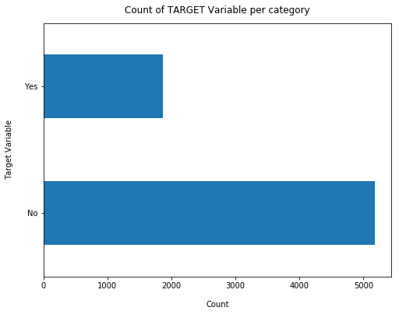

**In [10]:**

100**\***telco_base_data['Churn']**.**value_counts()**/**len(telco_base_data['Churn'])

**Out[10]:**

No 73.463013

Yes 26.536987

Name: Churn, dtype: float64

**In [11]:**

telco_base_data['Churn']**.**value_counts()

**Out[11]:**

No 5174

Yes 1869

Name: Churn, dtype: int64

* **Data is highly imbalanced, ratio = 73:27**
* **So we analyse the data with other features while taking the target values separately to get some insights.**

**In [12]:**

***# Concise Summary of the dataframe, as we have too many columns, we are using the verbose = True mode***

telco_base_data**.**info(verbose **=** **True**)

<class 'pandas.core.frame.DataFrame'>

RangeIndex: 7043 entries, 0 to 7042

Data columns (total 21 columns):

customerID 7043 non-null object

gender 7043 non-null object

SeniorCitizen 7043 non-null int64

Partner 7043 non-null object

Dependents 7043 non-null object

tenure 7043 non-null int64

PhoneService 7043 non-null object

MultipleLines 7043 non-null object

InternetService 7043 non-null object

OnlineSecurity 7043 non-null object

OnlineBackup 7043 non-null object

DeviceProtection 7043 non-null object

TechSupport 7043 non-null object

StreamingTV 7043 non-null object

StreamingMovies 7043 non-null object

Contract 7043 non-null object

PaperlessBilling 7043 non-null object

PaymentMethod 7043 non-null object

MonthlyCharges 7043 non-null float64

TotalCharges 7043 non-null object

Churn 7043 non-null object

dtypes: float64(1), int64(2), object(18)

memory usage: 1.1+ MB

**In [13]:**

missing **=** pd**.**DataFrame((telco_base_data**.**isnull()**.**sum())**\***100**/**telco_base_data**.**shape[0])**.**reset_index()

plt**.**figure(figsize**=**(16,5))

ax **=** sns**.**pointplot('index',0,data**=**missing)

plt**.**xticks(rotation **=**90,fontsize **=**7)

plt**.**title("Percentage of Missing values")

plt**.**ylabel("PERCENTAGE")

plt**.**show()

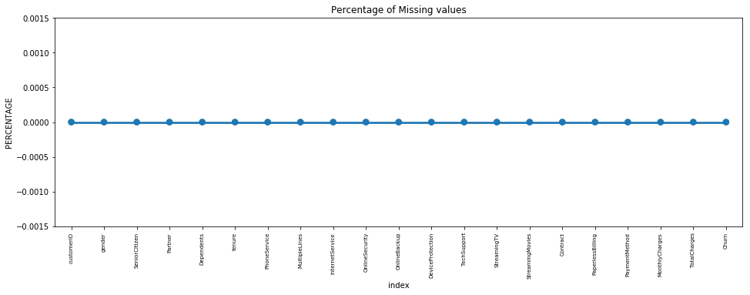

**Missing Data - Initial Intuition**

* Here, we don't have any missing data.

General Thumb Rules:

* For features with less missing values- can use regression to predict the missing values or fill with the mean of the values present, depending on the feature.
* For features with very high number of missing values- it is better to drop those columns as they give very less insight on analysis.
* As there's no thumb rule on what criteria do we delete the columns with high number of missing values, but generally you can delete the columns, if you have more than 30-40% of missing values. But again there's a catch here, for example, Is_Car & Car_Type, People having no cars, will obviously have Car_Type as NaN (null), but that doesn't make this column useless, so decisions has to be taken wisely.

**Data Cleaning**

**1. Create a copy of base data for manupulation & processing**

**In [14]:**

telco_data **=** telco_base_data**.**copy()

**2. Total Charges should be numeric amount. Let's convert it to numerical data type**

**In [15]:**

telco_data**.**TotalCharges **=** pd**.**to_numeric(telco_data**.**TotalCharges, errors**=**'coerce')

telco_data**.**isnull()**.**sum()

**Out[15]:**

customerID 0

gender 0

SeniorCitizen 0

Partner 0

Dependents 0

tenure 0

PhoneService 0

MultipleLines 0

InternetService 0

OnlineSecurity 0

OnlineBackup 0

DeviceProtection 0

TechSupport 0

StreamingTV 0

StreamingMovies 0

Contract 0

PaperlessBilling 0

PaymentMethod 0

MonthlyCharges 0

TotalCharges 11

Churn 0

dtype: int64

**3. As we can see there are 11 missing values in TotalCharges column. Let's check these records**

**In [14]:**

telco_data**.**loc[telco_data ['TotalCharges']**.**isnull() **==** **True**]

**OUT [14]:**

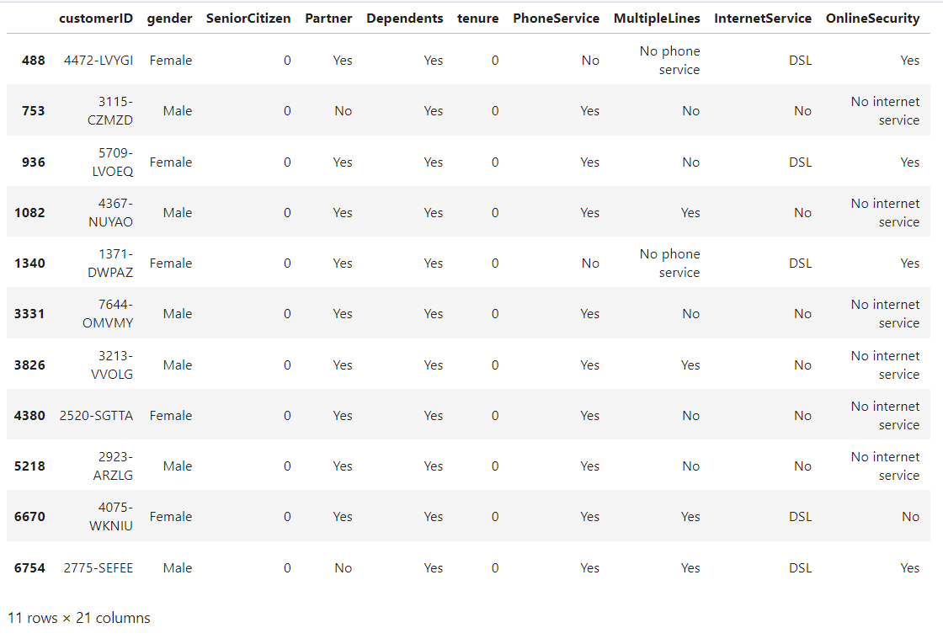

**4. Missing Value Treatement**

Since the % of these records compared to total dataset is very low ie 0.15%, it is safe to ignore them from further processing.

**In [15]:**

***#Removing missing values***

telco_data**.**dropna(how **=** 'any', inplace **=** **True**)

***#telco_data.fillna(0)***

**5.** **Divide customers into bins based on** tenure e.g. for tenure < 12 months: assign a tenure group if 1-12, for tenure between 1 to 2 Yrs, tenure group of 13-24; so on...

**In [16]:**

***# Get the max tenure***

print(telco_data['tenure']**.**max()) *#72*

72

**In [18]:**

***# Group the tenure in bins of 12 months***

labels **=** ["{0} - {1}"**.**format(i, i **+** 11) **for** i **in** range(1, 72, 12)]

telco_data['tenure_group'] **=** pd**.**cut(telco_data**.**tenure, range(1, 80, 12), right**=False**, labels**=**labels)

**In [19]:**

telco_data['tenure_group']**.**value_counts()

**Out[19]:**

1 - 12 2175

61 - 72 1407

13 - 24 1024

49 - 60 832

25 - 36 832

37 - 48 762

Name: tenure_group, dtype: int64

**6. Remove columns not required for processing**

**In [20]:**

*#drop column customerID and tenure*

telco_data**.**drop(columns**=** ['customerID','tenure'], axis**=**1, inplace**=True**)

telco_data**.**head()

**OUT[20]:**

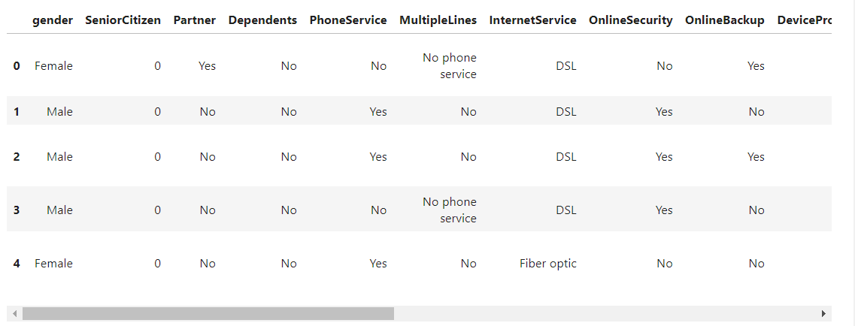

**Data Exploration**

**1. Plot distibution of individual predictors by churn**

**Univariate Analysis**

**In [20]:**

**for** i, predictor **in** enumerate(telco_data**.**drop(columns**=**['Churn', 'TotalCharges', 'MonthlyCharges'])):

plt**.**figure(i)

sns**.**countplot(data**=**telco_data, x**=**predictor, hue**=**'Churn')

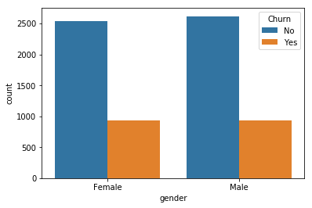

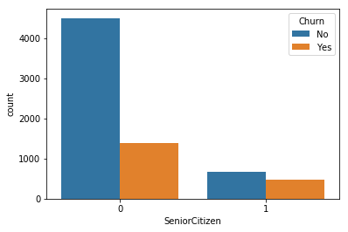

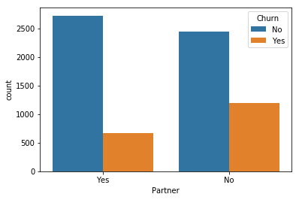

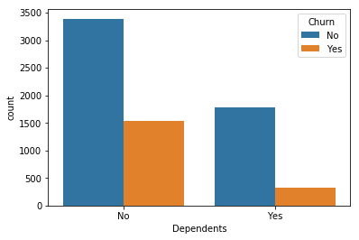

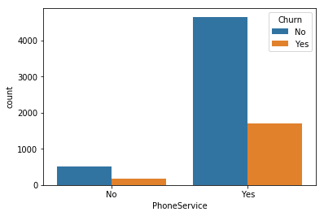

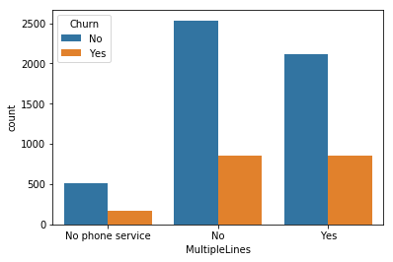

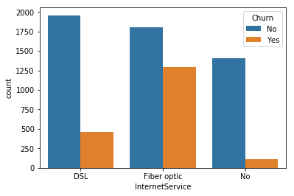

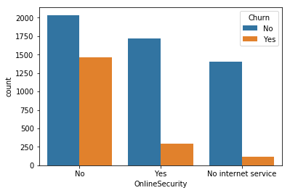

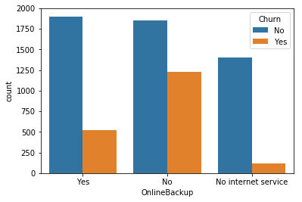

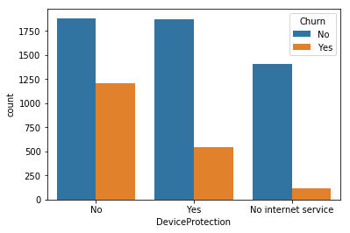

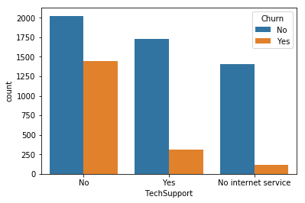

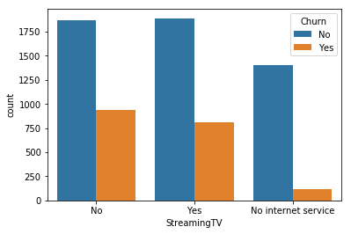

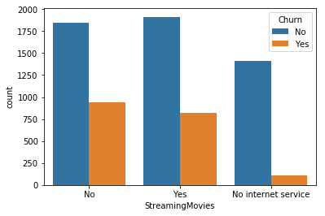

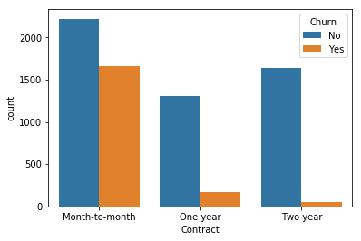

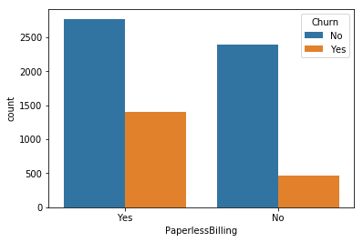

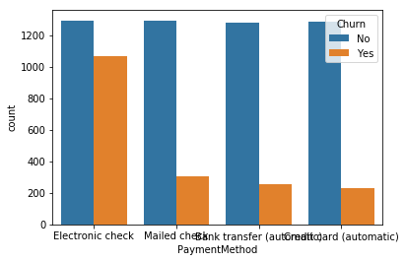

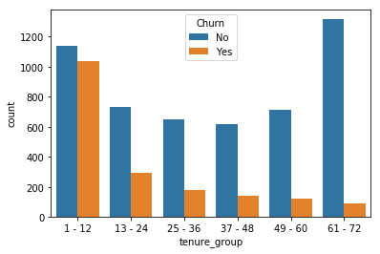

**2.** **Convert the target variable 'Churn' in a binary numeric variable i.e. Yes=1 ; No = 0**

**In [21]:**

telco_data['Churn'] **=** np**.**where(telco_data**.**Churn **==** 'Yes',1,0)

**In [22]:**

telco_data**.**head()

**3. Convert all the categorical variables into dummy variables**

**In [23]:**

telco_data_dummies **=** pd**.**get_dummies(telco_data)

telco_data_dummies**.**head()

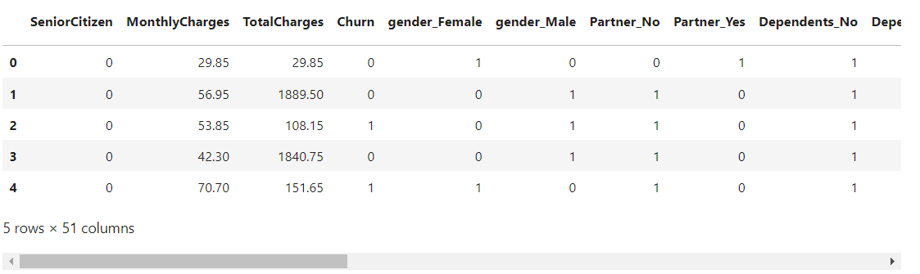

**9. Relationship between Monthly Charges and Total Charges**

**In [24]:**

sns**.**lmplot(data**=**telco_data_dummies, x**=**'MonthlyCharges', y**=**'TotalCharges', fit_reg**=False**)

**Out[24]:**

<seaborn.axisgrid.FacetGrid at 0x20d8a9289e8>

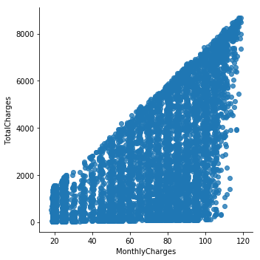

**Total Charges increase as Monthly Charges increase - as expected.**

**10. Churn by Monthly Charges and Total Charges**

**In [25]:**

Mth=sns**.**kdeplot(telco_data_dummies**.**MonthlyCharges[(telco_data_dummies["Churn"] **==** 0) ],

color**=**"Red", shade **=** **True**)

Mth=sns**.**kdeplot(telco_data_dummies**.**MonthlyCharges[(telco_data_dummies["Churn"] **==** 1) ],

ax **=**Mth, color**=**"Blue", shade**=** **True**)

Mth**.**legend(["No Churn","Churn"],loc**=**'upper right')

Mth**.**set_ylabel('Density')

Mth**.**set_xlabel('Monthly Charges')

Mth**.**set_title('Monthly charges by churn')

**Out[25]:**

Text(0.5, 1.0, 'Monthly charges by churn')

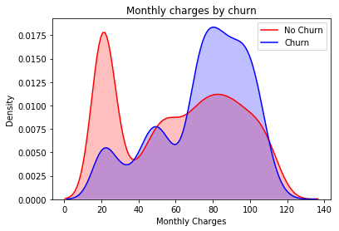

**Insight:** Churn is high when Monthly Charges ar high

**In [26]:**

Tot **=** sns**.**kdeplot(telco_data_dummies**.**TotalCharges[(telco_data_dummies["Churn"] **==** 0) ],

color**=**"Red", shade **=** **True**)

Tot **=** sns**.**kdeplot(telco_data_dummies**.**TotalCharges[(telco_data_dummies["Churn"] **==** 1) ],

ax **=**Tot, color**=**"Blue", shade**=** **True**)

Tot**.**legend(["No Churn","Churn"],loc**=**'upper right')

Tot**.**set_ylabel('Density')

Tot**.**set_xlabel('Total Charges')

Tot**.**set_title('Total charges by churn')

C:\Users\pattn\AppData\Local\Continuum\anaconda3\lib\site-packages\statsmodels\nonparametric\kde.py:444: RuntimeWarning: invalid value encountered in greater

X = X[np.logical_and(X > clip[0], X < clip[1])] # will not work for two columns.

C:\Users\pattn\AppData\Local\Continuum\anaconda3\lib\site-packages\statsmodels\nonparametric\kde.py:444: RuntimeWarning: invalid value encountered in less

X = X[np.logical_and(X > clip[0], X < clip[1])] # will not work for two columns.

**Out[26]:**

Text(0.5, 1.0, 'Total charges by churn')

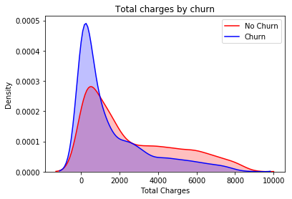

**Surprising insight**as higher Churn at lower Total Charges

However if we combine the insights of 3 parameters i.e. Tenure, Monthly Charges & Total Charges then the picture is bit clear :- Higher Monthly Charge at lower tenure results into lower Total Charge. Hence, all these 3 factors viz **Higher Monthly Charge**, **Lower tenure** and **Lower Total Charge** are linkd to **High Churn**.

**11. Build a corelation of all predictors with 'Churn'**

**In [27]:**

plt**.**figure(figsize**=**(20,8))

telco_data_dummies**.**corr()['Churn']**.**sort_values(ascending **=** **False**)**.**plot(kind**=**'bar')

**Out[27]:**

<matplotlib.axes._subplots.AxesSubplot at 0x20d8a979f98>

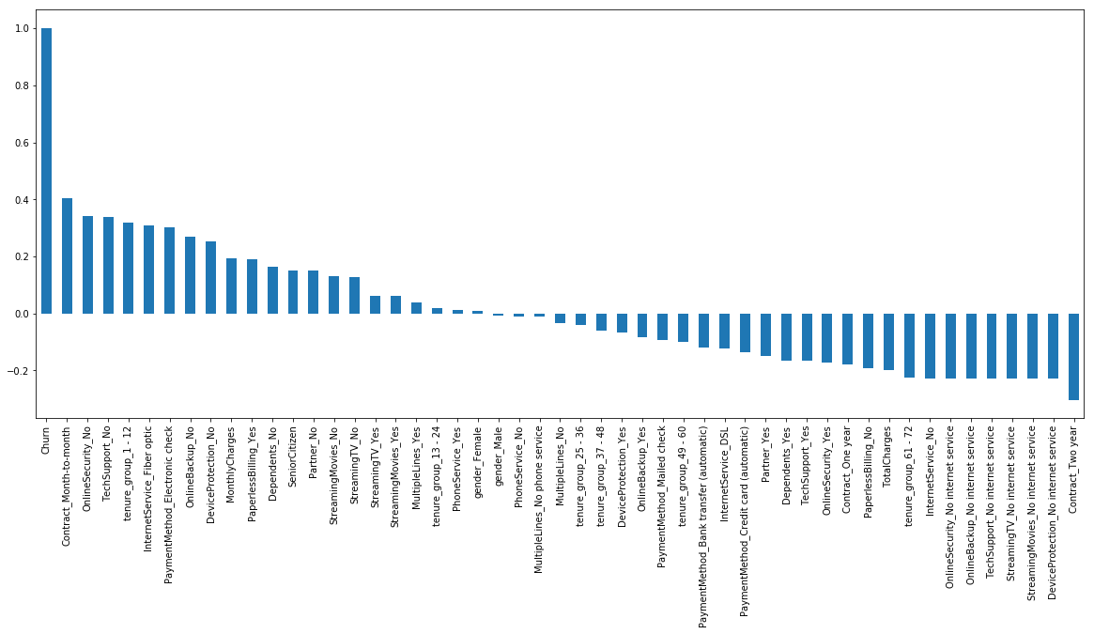

**Derived Insight:**

**HIGH** Churn seen in case of **Month to month contracts**, **No online security**, **No Tech support**, **First year of subscription** and **Fibre Optics Internet**

**LOW** Churn is seens in case of **Long term contracts**, **Subscriptions without internet service** and **The customers engaged for 5+ years**

Factors like **Gender**, **Availability of PhoneService** and **# of multiple lines** have alomost **NO** impact on Churn

This is also evident from the **Heatmap** below

**In [28]:**

plt**.**figure(figsize**=**(12,12))

sns**.**heatmap(telco_data_dummies**.**corr(), cmap**=**"Paired")

**Out[28]:**

<matplotlib.axes._subplots.AxesSubplot at 0x1809ebfef60>

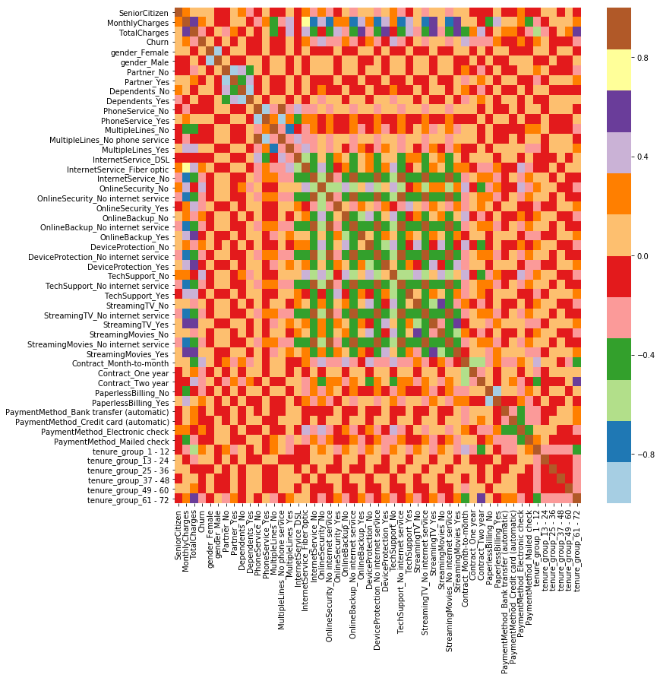

### Bivariate Analysis

**In [31]:**

new_df1_target0**=**telco_data**.**loc[telco_data["Churn"]**==**0]

new_df1_target1**=**telco_data**.**loc[telco_data["Churn"]**==**1]

**In [32]:**

**def** uniplot(df,col,title,hue **=None**):

sns**.**set_style('whitegrid')

sns**.**set_context('talk')

plt**.**rcParams["axes.labelsize"] **=** 20

plt**.**rcParams['axes.titlesize'] **=** 22

plt**.**rcParams['axes.titlepad'] **=** 30

temp **=** pd**.**Series(data **=** hue)

fig, ax **=** plt**.**subplots()

width **=** len(df[col]**.**unique()) **+** 7 **+** 4**\***len(temp**.**unique())

fig**.**set_size_inches(width , 8)

plt**.**xticks(rotation**=**45)

plt**.**yscale('log')

plt**.**title(title)

ax **=** sns**.**countplot(data **=** df, x**=** col, order**=**df[col]**.**value_counts()**.**index,hue **=** hue,palette**=**'bright')

plt**.**show()

**In [33]:**

uniplot(new_df1_target1,col**=**'Partner',title**=**'Distribution of Gender for Churned Customers',hue**=**'gender')

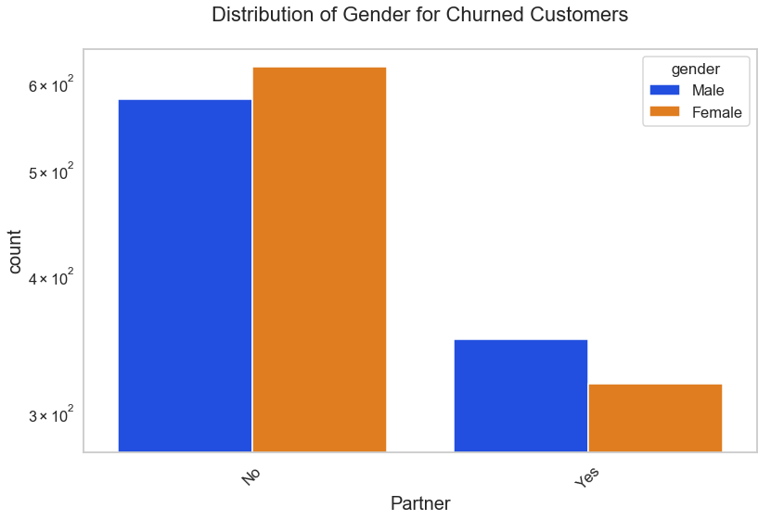

**In [34]:**

uniplot(new_df1_target0,col**=**'Partner',title**=**'Distribution of Gender for Non Churned Customers',hue**=**'gender')

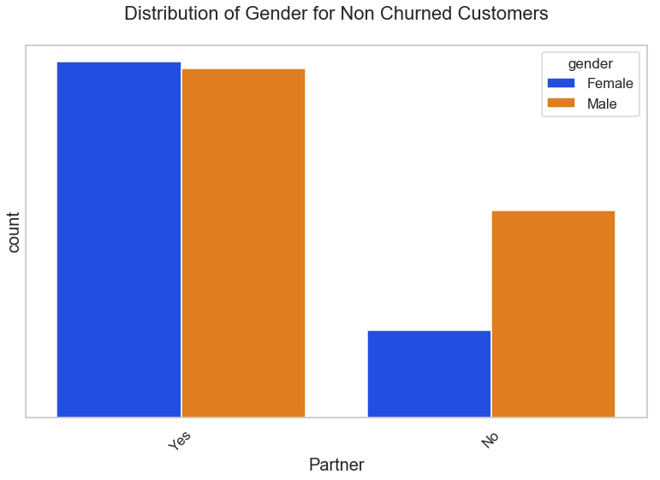

**In [35]:**

uniplot(new_df1_target1,col**=**'PaymentMethod',title**=**'Distribution of PaymentMethod for Churned Customers',hue**=**'gender')

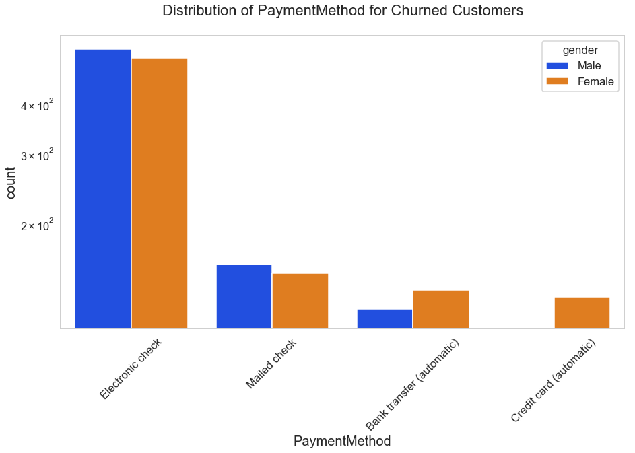

In [36]:

uniplot(new_df1_target1,col**=**'Contract',title**=**'Distribution of Contract for Churned Customers',hue**=**'gender')

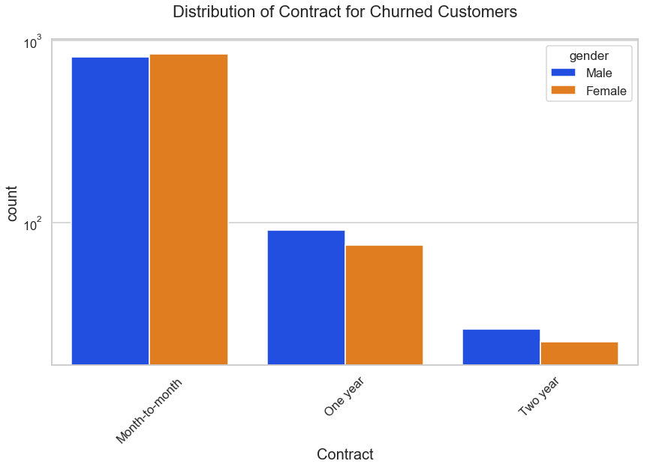

**In [37]:**

uniplot(new_df1_target1,col**=**'TechSupport',title**=**'Distribution of TechSupport for Churned Customers',hue**=**'gender')

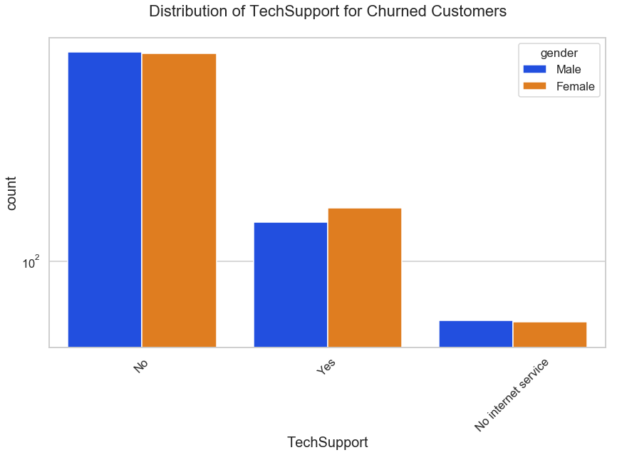

In [38]:

uniplot(new_df1_target1,col**=**'SeniorCitizen',title**=**'Distribution of SeniorCitizen for Churned Customers',hue**=**'gender')

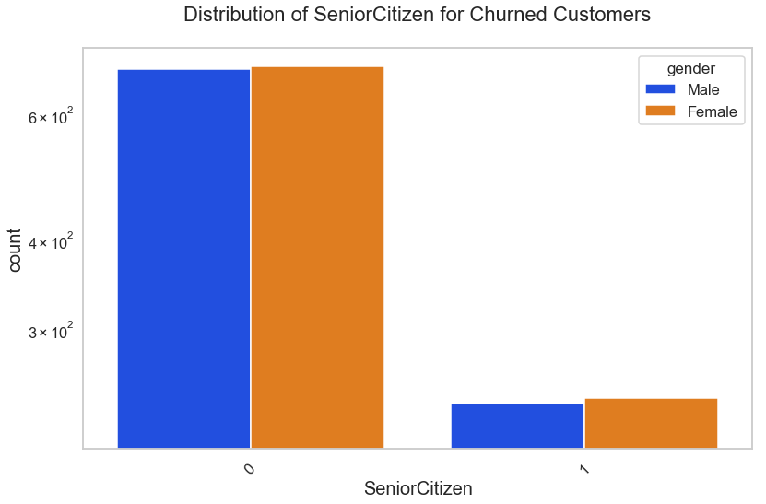

# **CONCLUSION**

These are some of the quick insights from this **development part 1**:

1. Electronic check medium are the highest churners
2. Contract Type - Monthly customers are more likely to churn because of no contract terms, as they are free to go customers.
3. No Online security, No Tech Support category are high churners
4. Non senior Citizens are high churners